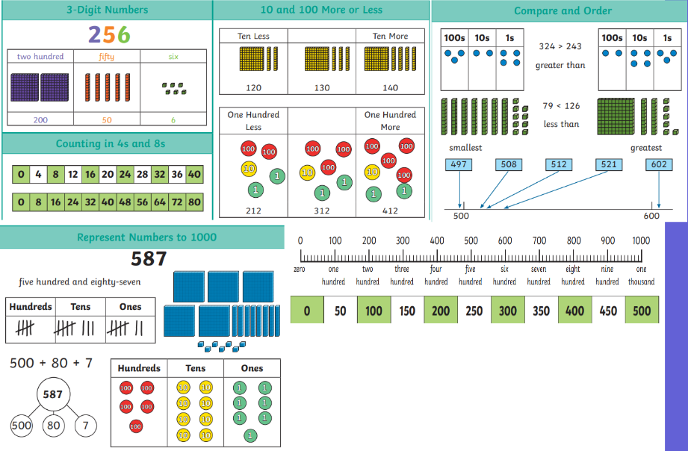

Vocabulary

Thousands, Hundreds, Tens, Ones, Zero, Place Value, Greater than, Less than, Order, Partition, Digit, Numerals, After, Before, Total, Groups, Represent, Value, Whole, Parts, Explain, Greatest, Smallest, Estimate, Interval.

Skills

REPRESENT numbers to 100

PARTITION numbers to 100

RECOGNISE number lines to 100

UNDERSTAND 100s

REPRESENT numbers to 1000

PARTITION numbers to 1000

Flexibly PARTITION numbers to 1000

UNDERSTAND hundreds, tens and ones

FIND 1, 10, 100 more or less

RECOGNISE number lines to 1000

COMPARE numbers to 1000

ORDER numbers to 1000

COUNT in 50s

Subject: Maths Y3 T1

Place Value

LINKS:

revisit and consolidate numbers to 100 in Year 2

confident using a range of manipulatives.

By the end of the block, children should know –

[](https://www.google.co.uk/url?sa=i&rct=j&q=&esrc=s&source=images&cd=&cad=rja&uact=8&ved=2ahUKEwi7496YybXdAhUsAsAKHSQzDOoQjRx6BAgBEAU&url=http://www.diocant-aquila.org/Kingsnorth-CE-Primary-School&psig=AOvVaw3awRi5GUGB9PYUIiFKTqrv&ust=1536845345048273)

KINGSNORTH SUBJECT ORGANISER