Skills
- To explain
- To identify
- To explore
- To raise questions
- To collect and record data

By the end of the block, children should know –
- That unsupported objects fall towards the earth because of the force of gravity acting between the earth and the falling object.
- The effects of air resistance, water resistance and friction that act between moving surfaces.
- That some mechanisms, including levers, pulleys and gears, allow a smaller force to have a greater effect.
BIG QUESTION
I wonder how many forces you encounter in a day?
What would life look like without forces?

Subject
___Science ___
Term 2__
‘Forces’

Vocabulary
Gravity Friction
Resistance Lever
Mechanisms Buoyancy
Effective Exert/Apply
Forces Repel/Attract
Thrust

Key Figures
Galileo and Issac Newton

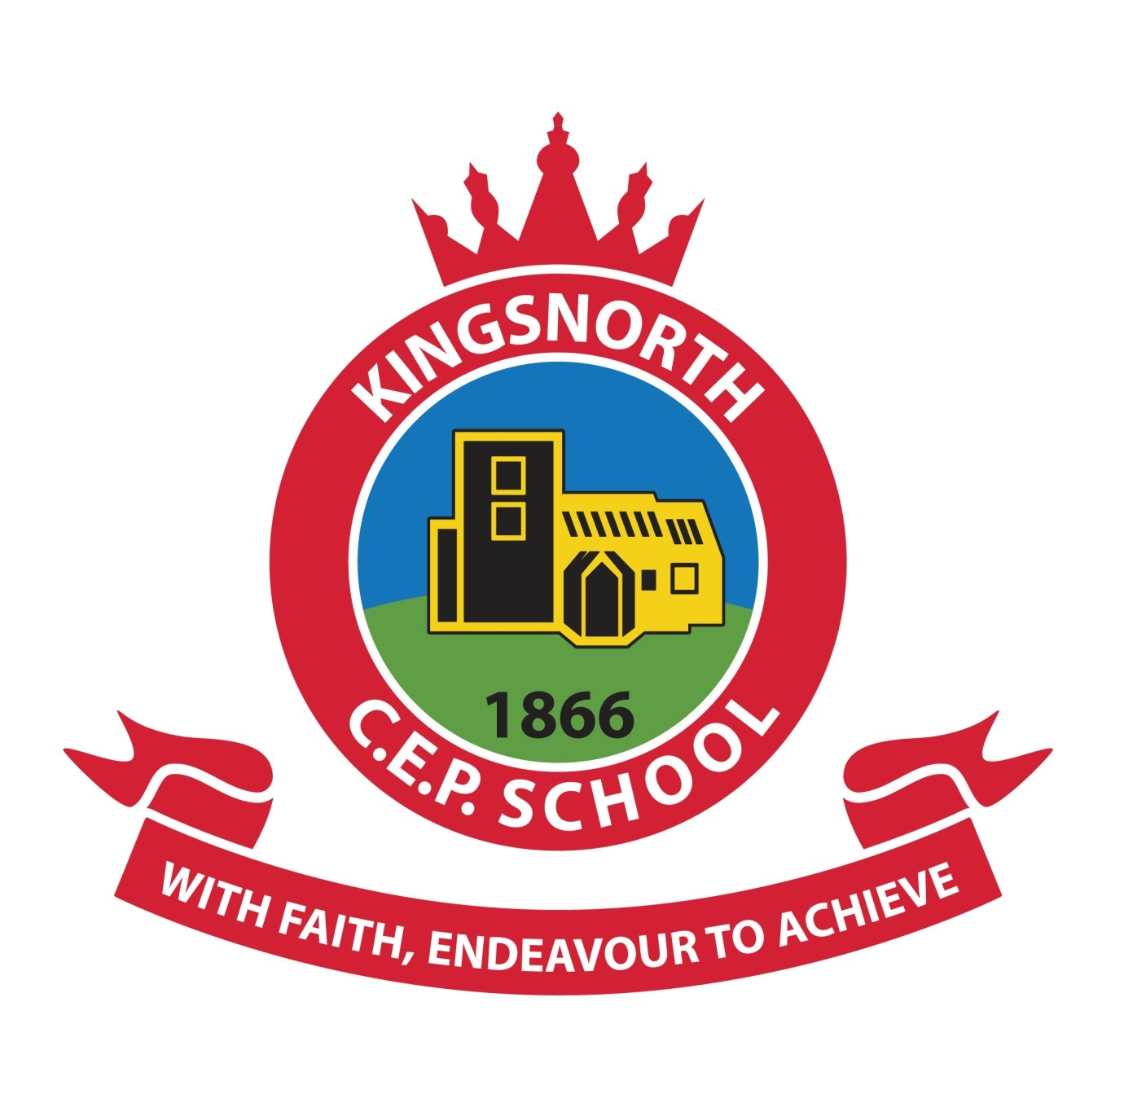
KINGSNORTH SUBJECT ORGANISER

What I already know | What I’d like to know | What I have learnt

