QUESTION STEMS BY READING STRAND
Words in Context
- What other words could the author use to describe the main character?
- How has the author’s words made you feel about the character?
- Which words do you think are the most important and why?
Retrieve Information
- When/where/how is the story set? What evidence can you find to support this?
- Through whose eyes is the story told?
- Where in the text would you find…?
- Which part of the story best describes…?
Summarise main ideas
- Summarise the story so far.
- What is the main point in this paragraph?
- What is the most important point of this paragraph?
Inference / justify views
- How does the character feel? How do you know? (show not tell)
- Why has the character acted in this way?
- Which words give you the impression that…?
Predict using details
- What challenges might the character face?
- How might the story end? What are the clues?
- Will the setting influence how the story develops?
Language choice
- Why has the author chosen these adjectives?
- What does this word/phrase tell you about the mood/setting or character?
- How has the author made you feel happy/angry/sad/frustrated…?
Making comparisons
- Does this book remind you of another one?
- How are characters same / different?

EXPECTED RAPID RECALL FACTS BY END OF YEAR 3
- Counting and place value
  - To count in multiples of 100, 50, 4 and 8.
  - Understand the value of H,T and Ones.
  - Count in 3s and 4s from any given number forwards and backwards.
- Number bonds
  - Know number bonds to 100
  - Understand that = balances an equation
- Addition and subtraction
  - Add and subtract mentally a 3-digit number and ones, tens and hundreds.
  - Know all addition and subtraction facts for multiples of 100 to 1000
- Doubling and Halving
  - Know doubles and halves of multiples of 10 to 5000
- Multiplication and division
  - Multiplication and division facts for 3x, 4x, 8x
  - Recognise that multiples of even times tables are all even.
- Measures
  - 1kg = 1000g / ½ kg = 500g
  - 1 litre = 1000ml / ½ l = 500ml
  - 1km = 1000m / ½ km = 500m
  - 1m = 100cm / ½ m = 50cm
  - Recognise right angles
- Time
  - 1 hour = 60 minutes
  - 1 minute = 60 seconds
  - 24 hours = 1 day
  - 365 days = 1 year
  - 12 months = 1 year
- Tell time
- To the nearest 1 minute.



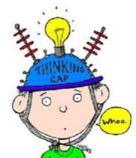

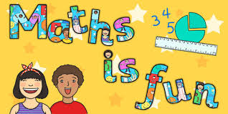
Year 3 Key skills for Reading and for Maths
End of year expectations



