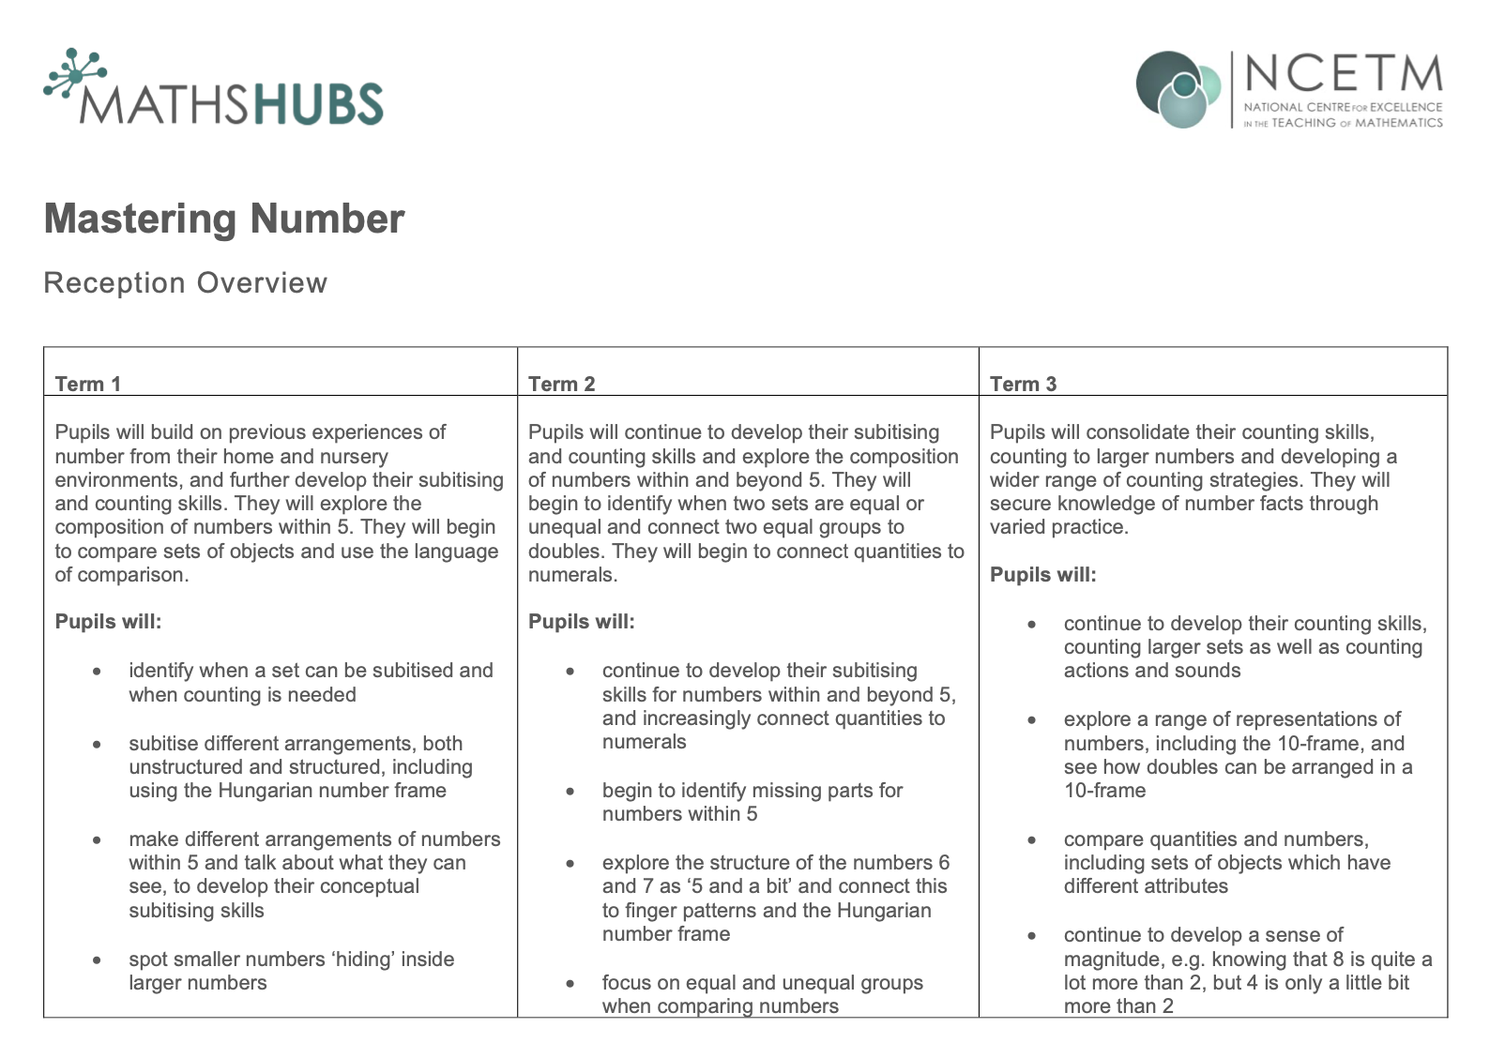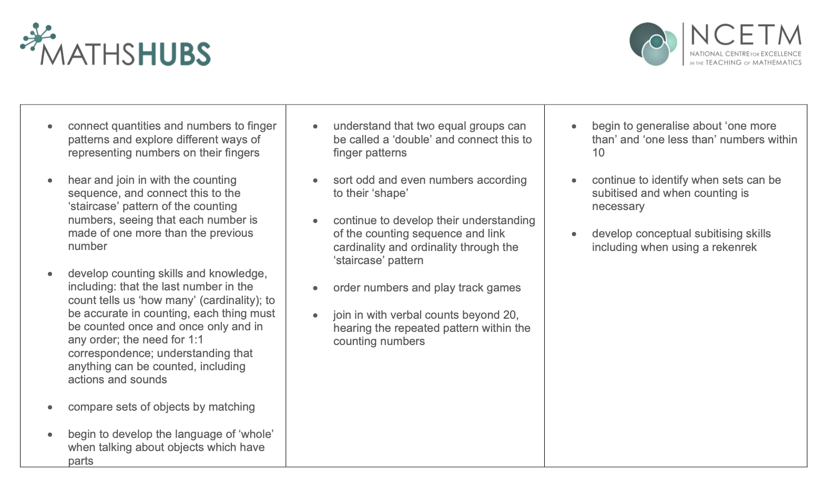

YR | 1 | 2 | 3 | 4 | 5 | 6 | 7 | 8 | 9 | 10 | 11 | 12
Autumn | Early mathematical experiences |  |  |  |  |  | Pattern |  | Shape and sorting |  | Position and direction
Spring | Measure  Ordering size, length, weight, capacity |  |  |  | Calendar and time |  |  |  | Shape
Summer | Grouping and sharing |  |  |  |  | Money |  | Measure |  | Consolidation
Mastering number 4 x per week
Oak academy 1 x per week of units below

Y1 | 1 | 2 | 3 | 4 | 5 | 6 | 7 | 8 | 9 | 10 | 11 | 12
Autumn | Counting, recognising and comparing numbers 0 – 10 |  |  | Counting to and from 20 |  | Counting in tens - decade numbers | Pattern in counting from 20 to 100 | Comparing quantities - part part whole relationships |  |  | Composition of numbers 0 to 5
Spring | Recognise, compose, decompose and manipulate 2D and 3D shapes |  |  | Composition of numbers 6 to 10 |  |  | Additive structures: addition |  | Additive structures: addition and subtraction |  | Addition and subtraction facts within 10  (3 weeks)
Summer | Composition of numbers 11 to 19 |  | Numbers 0 to 20 in different contexts |  | Unitising and coin recognition - counting in 2s, 5s and 10s |  | Unitising and coin recognition - value of a set of coins |  | Solving problems | Position and direction including | Time - sequencing events and telling the time to the hour and half hour
 |  |  |  |  |  |  |  |  | in a range of contexts | Position and direction including
 |  |  |  |  |  |  |  |  |  | fractions of turns

Place value
Geometry & Measure
Addition/Subtraction
Multiplication/Division
Fractions

Y2 | 1 |  | 2 | 3 | 4 | 5 | 6 | 7 | 8 |  | 9 |  | 10 | 11 | 12
Autumn | Composition of multiples of 10 |  |  | Counting and representing the | Comparing, ordering and partitioning 2-digit numbers | Secure fluency of addition and subtraction facts within 10 | Calculating within 20 |  |  | Adding and subtracting ones and tens to and from 2-digit numbers |  |  |  |  | Grouping objects in different ways and relating to multiplication
Autumn |  |  |  | numbers 20 to 99 | Comparing, ordering and partitioning 2-digit numbers | Secure fluency of addition and subtraction facts within 10
Spring | Grouping objects in different ways and relating to  multiplication |  | Representing counting in 2s, 5s and 10s as the 2, 5 and 10 times tables |  | Representing counting in 5s as the 5 times table and link to the 10 times tables |  | Multiplying by 2, doubling and halving (factors and products) | Introduction to division structures |  |  | Shape: discuss and compare 2D and 3D shapes |  |  | Addition and subtraction of two 2-digit numbers
Summer | Addition and subtraction of two 2-digit numbers | Money: recognise coins and use £ and p symbols |  | Fractions: identify equal parts and be familiar with halves, thirds and quarters |  | Time: write and tell the time to five minutes | Position and direction | Doubling, halving, quotative and partitive division |  |  |  | Sense of measure - capacity, volume and mass |  |  | Consolidation
Place value
Geometry & Measure
Addition/Subtraction
Multiplication/Division
Fractions
Statistics
Y3 | 1 | 2 | 3 |  | 4 | 5 | 6 | 7 | 8 |  | 9 |  |  | 10 | 11 | 12
Autumn | Review strategies for adding and subtracting across 10 |  | Securing place value to 100 and applying to addition and subtraction |  |  | Bridging 100: counting on and back in 10s, adding/subtracting | Measuring length and recording in tables |  | Representing 3-digit numbers, comparing and positioning on number lines |  |  |  |  |  | Measures: mass and capacity
Autumn |  |  |  |  |  | multiples of 10
Spring | Right angles |  | Informal and mental strategies for adding and subtracting two 3-digit numbers |  |  | Understand additive relationships and apply them to rearrange equations |  | Column addition |  |  | 2, 4 and 8 times tables: using times tables to solve problems |  |  |  |  | Column subtraction
Summer | Unit fractions as part of a whole |  | Identify parts and wholes in different contexts | Compare and order unit fractions |  | Calculate the value of a part (fractions as operators) | Non-unit fractions |  |  | Composition of non-unit fractions: addition and subtraction |  |  | Parallel and perpendicular sides in polygons |  |  | Tell the time to the nearest
 |  |  |  |  |  |  |  |  |  |  |  |  |  |  |  | minute and compare
units of time
(2 weeks + 2 days)
Ratio and Proportion
Place value
Geometry & Measure
Addition/Subtraction
Multiplication/Division
Fractions
Statistics
Y4 | 1 |  | 2 | 3 | 4 | 5 | 6 | 7 | 8 | 9 | 10 | 11 | 12
Autumn | Review of column addition and subtraction |  |  |  | Secure place value to 1000: | Calculation and | Comparing, ordering and rounding 4-digit numbers | Column addition and subtraction with 4-digit numbers | Perimeter |  | Represent counting in threes and sixes as | Relationship between the 3 and 6 times tables and | Represent counting in nines as the 9 times table
Autumn |  |  |  |  | apply to addition and | conversion of measures
 |  |  |  |  |  |  |  |  |  |  | the 3 and 6 times tables | tests of divisibility | Represent counting in nines as the 9 times table
Autumn |  |  |  |  | subtraction: multiples of 100
Spring | Relationship between the 3 and 9 times tables |  | 7 times table: odd and even patterns, square numbers and tests of divisibility |  | Understand and represent multiplicative structures | Apply the distributive law to multiplication | Understand what happens when a number is multiplied or divided by 10 and 100 |  |  | Coordinates | Review of fractions | Composition of fractions greater than one | Compare and order mixed numbers and position on a number line
Summer | Addition and subtraction of fractions | Convert improper fractions to mixed numbers and vice versa |  | Efficient strategies for adding and subtracting mixed numbers (crossing a whole) | Properties of 2D and 3D shapes and symmetry |  | Money: apply efficient strategies when calculating with money |  | Time: Convert | Division with remainders |  | Consolidation | Consolidation
Summer | and mixed numbers (within a whole)
Place value
Geometry & Measure
Addition/Subtraction
Multiplication/Division
Fractions
Statistics
Y5 | 1 |  | 2 | 3 | 4 | 5 | 6 | 7 | 8 | 9 | 10 | 11 | 12
Autumn | Understand tenths as part of a whole |  | Compose and calculate | Understand hundredths | Use knowledge of decimals to solve problems in different contexts: length |  | Negative numbers |  | Multiplication by partitioning leading to short multiplication (2 by 1-digit) |  | Multiplication by partitioning leading to short | Division by partitioning leading to short division (2 and 3-digits by 1-digit)
Autumn |  |  | with decimals | as part of a whole |  |  |  |  |  |  | Multiplication by partitioning leading to short
 |  |  |  |  |  |  |  |  |  |  | multiplication (3 by 1-digit)
Spring | Division continued |  | Understand the concept of area | Link area of rectangles to multiplication |  | Compare and describe measurements using knowledge of multiplication and division |  | Calculating with decimal fractions |  |  | Understand the concept of | Multiply 3 or more numbers | Understand and use the concept of factorisation
Spring |  |  |  |  |  |  |  |  |  |  | volume |  | Understand and use the concept of factorisation
Summer | Use common factors and multiples to solve calculations efficiently | Multiply a proper fraction by a whole number |  | Multiply improper fractions and mixed numbers by a whole number | Find unit and non-unit fractions of whole numbers exploring parts and wholes |  | Comparing fractions using equivalence and decimals |  |  | Converting units |  | Angles: compare, name, estimate and measure angles  (3 weeks)

Place value
Geometry & Measure
Addition/Subtraction
Multiplication/Division
Fractions
Statistics

Y6 | 1 | 2 | 3 | 4 |  | 5 | 6 | 7 | 8 | 9 | 10 |  | 11 | 12
Autumn | Use knowledge of part-part-whole structure to solve additive problems |  | Use equivalence and compensation to simplify and solve addition calculations |  | Use equivalence and compensation to simplify and solve subtraction problems |  |  | Multiples of 1,000 |  | Understand place | Order, compare and calculate with numbers up to 8 digits |  |  | Rounding and solving
Autumn |  |  |  |  |  |  |  |  |  | value within |  |  |  | problems with
 |  |  |  |  |  |  |  |  |  | numbers with up to 7 digits |  |  |  | numbers up to 7 digits
Spring | Draw, compose and decompose shapes |  | Using equivalence to calculate | Multiplying and dividing by 2-digit numbers |  |  |  | Area, perimeter, position and |  | Addition and subtraction of fractions |  |  | Comparing fractions | Multiplication and division of fractions
Spring |  |  | Using equivalence to calculate |  |  |  |  | direction |  |  |  |  | Comparing fractions | Multiplication and division of fractions
Summer | Understanding percentages |  | Statistics | Ratio and proportion |  |  | Calculating using knowledge of | Solving problems with two |  | Order of operations |  | Mean average
Summer |  |  |  |  |  |  | equivalence in addition and subtraction | unknowns
Place value
Geometry & Measure
Addition/Subtraction
Multiplication/Division
Fractions
Statistics
Probability
Algebra
Ratio and proportion

