Vocabulary
Transport  Habitat  Energy  Farming  Leisure  Pollution  Environment  Global  Contaminants | Precipitation  Evaporation  Condensation  Transportation  Water Vapour  Erosion  Deposition  Water  Nutrients

Skills
- understand and explain the water cycle
- find out about rivers and how they erode, transport and deposit materials.
- find out why rivers are important
- find out about the causes of river pollution and the effect it has on the environment.
- investigate a river in detail including the effects on the environment and landscape.
- conduct a geographical enquiry

By the end of the block, children should know
- The water cycle is a way in which water moves around our planet. Without this cycle of water, plants would not grow and humans and animals would not survive.
- Rivers collect run-off from precipitation and transport it back to the ocean so the cycle can keep going
- Rivers, lakes, wetlands and other freshwater environments supply water that we need for drinking, growing food and other crops, producing energy and manufacturing all sorts of products. Rivers also act as transport routes and they provide fish that feed tens of millions of people.
- The River Thames is an important river in England
- Contaminants such as chemicals, nutrients, and heavy metals are carried from farms, factories, and cities by streams and rivers into our bays and estuaries; from there they travel out to sea.
- How to use secondary sources.

GEOGRAPHY
Term 1 – Rivers and the water cycle.
How are rivers key to settlements and what impact do they have on the environment?

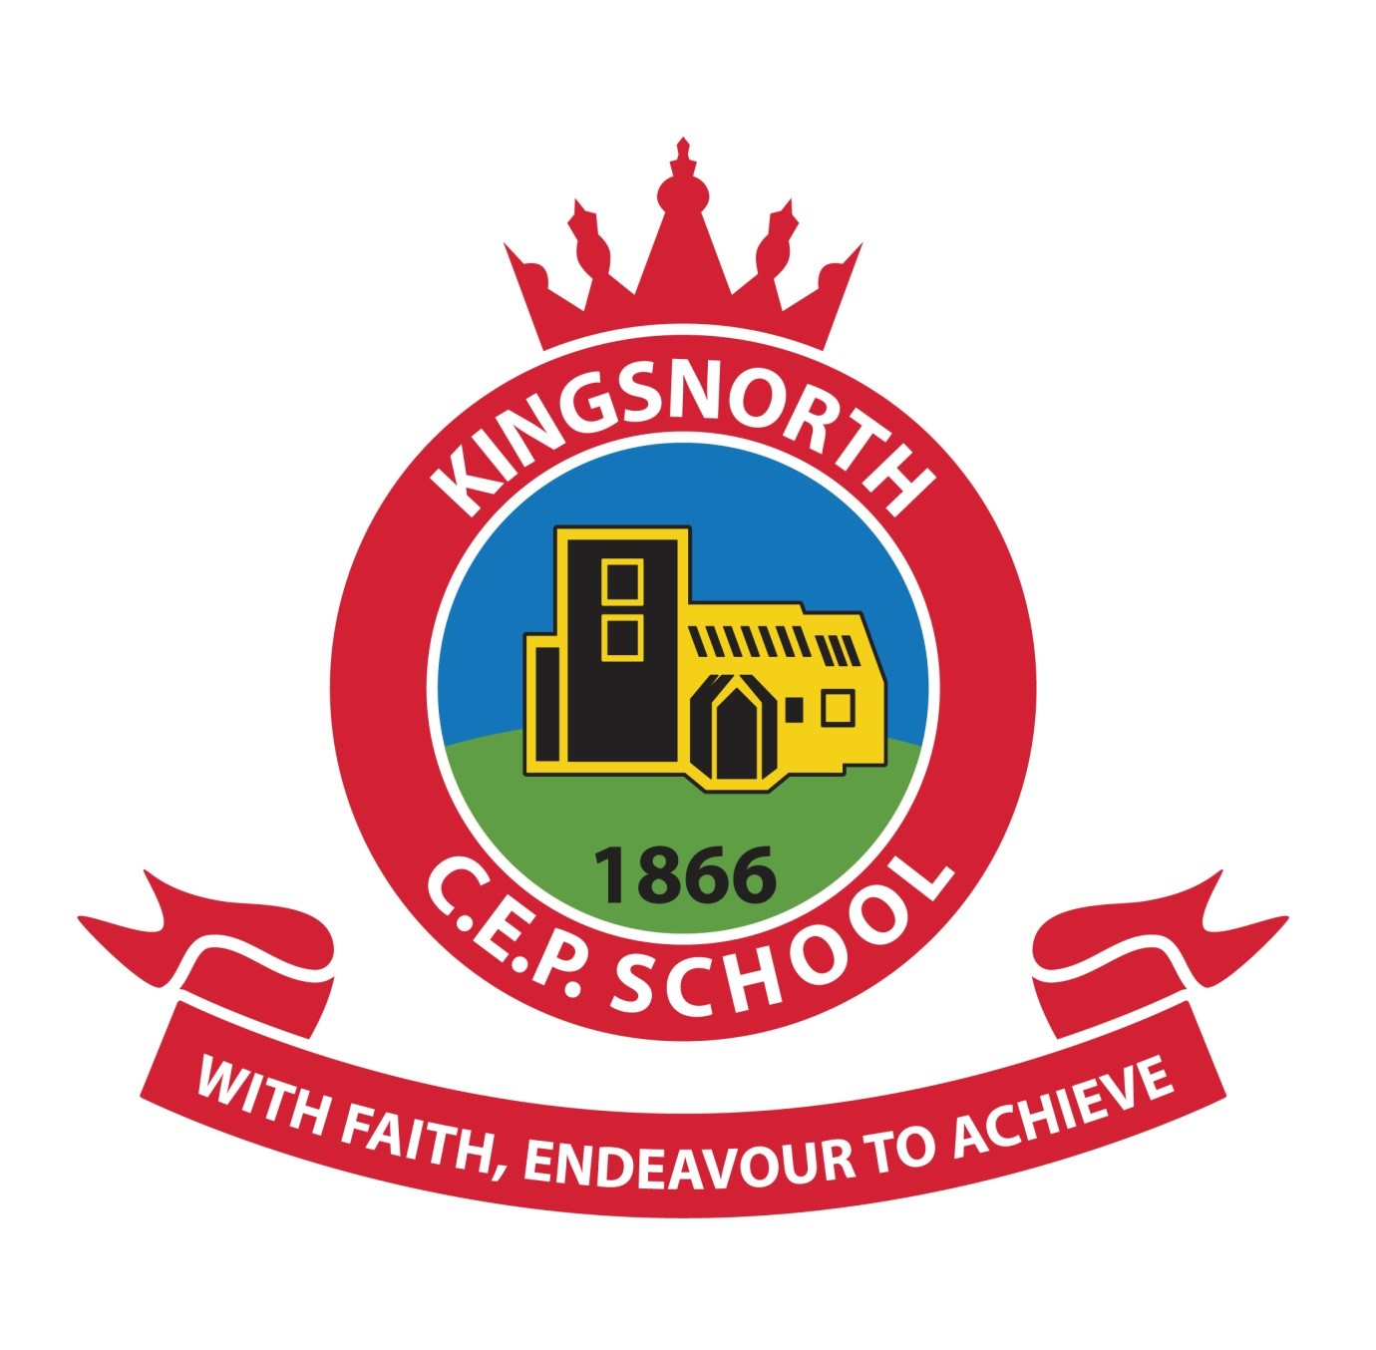
KINGSNORTH SUBJECT ORGANISER

