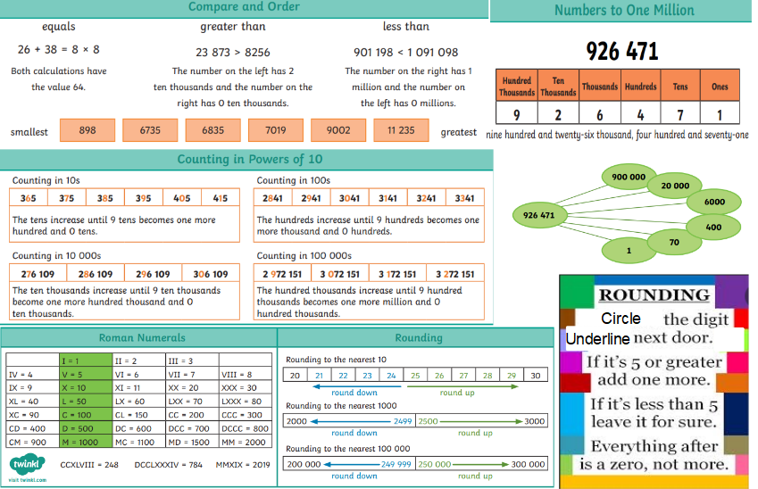
Vocabulary
Millions, Thousands, Hundreds, Tens, Ones, equal to, less than, greater than, Order, Round, Convert, Interval, Digit, Partition, Linear sequence, Represent, Estimate, Power, Multiple, Midpoint
By the end of the block, children should know –

Skills
RECOGNISE roman numerals to 1000
RECOGNISE numbers to 10,000
RECOGNISE numbers to 100,000
RECOGNISE numbers to 1,000,000
READ and WRITE numbers to 1,000,000
UNDERSTAND powers to 10
FIND 1, 10, 100, 1000, 10,000, 100,000 more or less
PARTITION numbers to 1,000,000
CONSTRUCT number lines to 1,000,000
COMPARE and ORDER numbers to 100,000
COMPARE and ORDER numbers to 1,000,000
ROUND to nearest 10, 100 and 1000
ROUND within 100,000
ROUND within 1,000,000

Subject: Maths Y5 T1
Place Value
LINKS:
Roman numerals to 100 in Year 4
Revise learning numbers up to 10,000
Develop reading and writing large numbers

KINGSNORTH SUBJECT ORGANISER

