SUGGESTIONS FOR SPELLING SESSIONS

Rainbow writing  Syllables  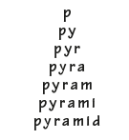  Tricky part of word | - What patterns can you see?  - What is the focus sound? Where does it belong on the sound chart?  - What might be tricky? Why? How can we remember these parts?  - How many syllables are there in each word? Clap them!  - What are the sounds in each word? (Use dots and dashes to identify each sound)  - Is there a spelling rule associated with the focus? Are there any exceptions to the rule?  - Can you use a different coloured pencil to break down the tricky parts?  - Create pyramid shapes with the word
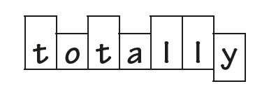  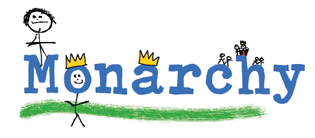 | - Say and repeat / cover and write – work on muscle memory!  - Draw around the word to show its shape – letter ascenders and descenders  - Create an image to remember the word  - Make words with single letters / scrabble pieces
Spelling games    Interactive ideas | Spelling Games  - Hangman  - Create mnemonics  - Spellzone (website) games  - Crosswords (available online)  - Remove vowels / consonants  .
Silly sentences | - Make up silly sentences. How many can you use in one sentence?  - Write down sentences on reverse side of spelling sheet.  - Underline spelling word / rainbow colour. Where does it come in a sentence?
More game ideas | - SPLAT  - Wordsearches / hangman  - Quick write – how many can you write in 1 minute?  - Test
Create a spelling journal  Practise words  Create memories  Investigate words  Draw words  Make up stories | 

