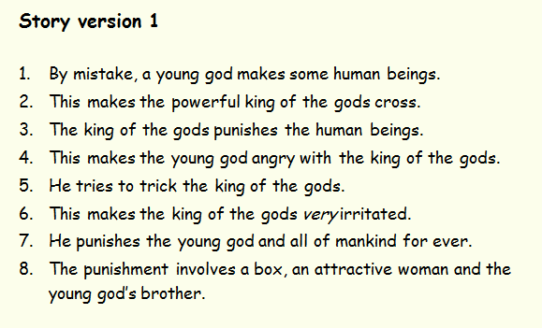
STORY VERSION 2:
1.A young god called Prometheus plays with some clay and accidentally makes some human beings.
2.Zeus, the powerful king of the gods, is annoyed because Prometheus didn’t have permission to make human beings.
3.Prometheus watches over the humans and is kind to them.
4.Zeus is jealous and outraged. He punishes the human beings even though they have done nothing wrong.
5.Prometheus is furious with Zeus for being unfair and feels sorry for the humans. He tries to fool the king of the gods.
6. The king of the gods is livid with Prometheus and wants to teach him a lesson.
7. Zeus shows his fury and his power by ordering a terrible punishment for Prometheus.
8. He also punishes all of mankind for evermore.
9. He has a box made that contains a secret. He gives the box to a beautiful woman called Pandora and introduces her to the brother of Prometheus.
10. Zeus uses Pandora and her box to punish the whole world without end.

FACT CARDS:


