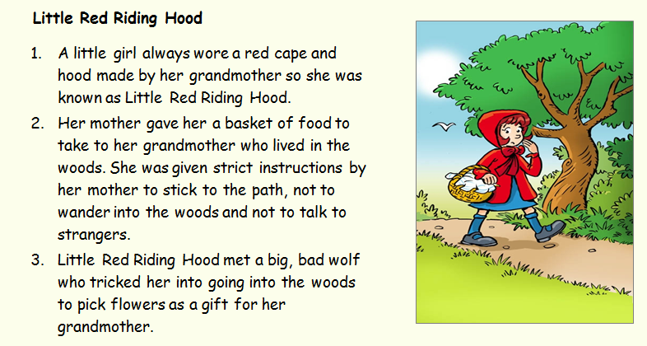
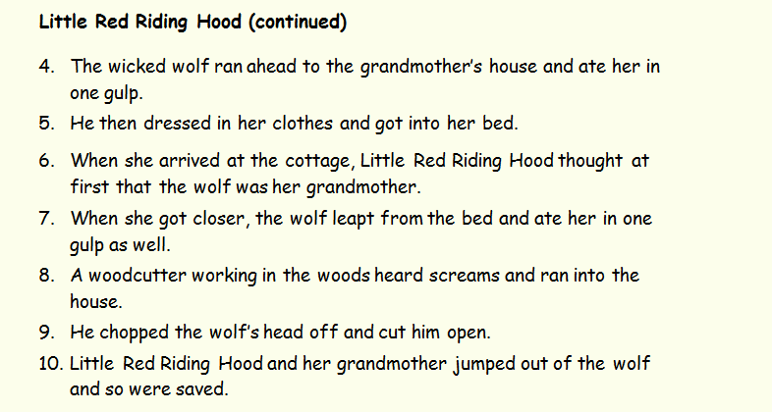
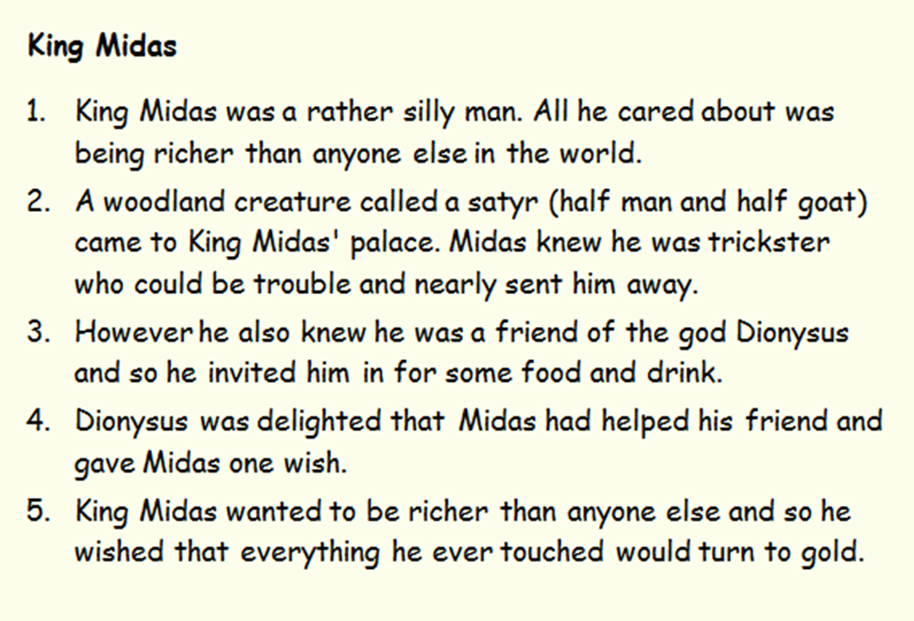
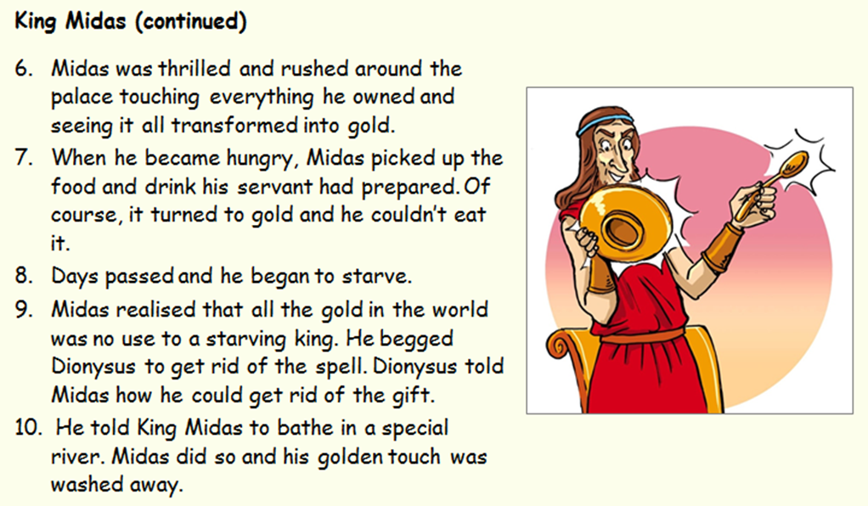

FEATURE | EVIDENCE FROM THE TEXT
FEATURE | LITTLE RED RIDING HOOD | KING MIDAS
A character in danger

A wicked or dangerous character

Instructions or orders to follow

A gift

Something a character wants

Magic

Setting

A lesson to be learnt

