ENGLISH – MYTH WRITING
TERM 3 WEEK 1
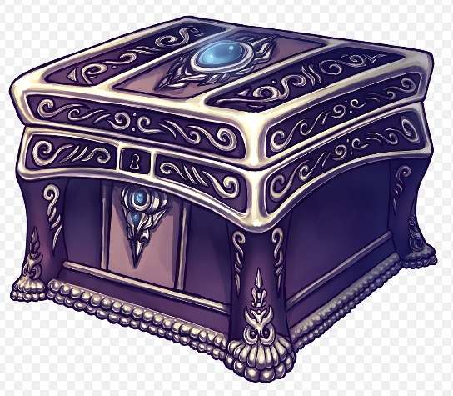
PANDORA’S BOX: To write a new ending for Prometheus and Pandora from Pandora’s point of view using ideas from the story and other traditional tales.
DAY | LEARNING OBJECTIVE | TASK | RESOURCES
TUESDAY | LO: To make connections  Today’s lesson is all about making connections between different genres. Today you will compare a traditional tale and a myth. | 1. What is a myth? Watch the clip to find out the special features of a myth.  2. Read Little Red Riding Hood and King Midas. Can you find evidence of the following features in both texts? Write your evidence for each in the grid provided. You might not be able to find evidence for all the features in both text, but you should see some connections between myths and traditional tales.  A character in danger.  A wicked or dangerous character  Instructions or orders to follow  A gift  Something a character wants  Magic  Setting  A lesson to be learnt | What is a myth: https://www.bbc.co.uk/bitesize/topics/zx339j6/articles/ztxwsrd  Little Red Riding Hood / King Midas text and grid to complete
WEDNESDAY | LO: To put a story into context  Today’s lesson is all about reading Version 1 and 2 of the Pandora’s Box myth and then finding out some facts to help you understand the world of Ancient Greece. | 1. Read story Version 1 and 2. Look at the extra details you find out!  2. Look at the fact cards. Write some facts you find out about Ancient Greece in your own words, presenting your work in any way you like. Make sure your presentation is beautiful and you are spelling the special Greek words correctly. | Story Version 1 and 2 / Greek facts
THURSDAY | LO: To use our knowledge  Today you will use the knowledge about Ancient Greek punishments to write your own! | 1. Look back at Story Version 2. Zeus punishes Prometheus at one point in the story.  2. Use your knowledge from the fact cards yesterday to write what you think the punishment could be! Try to think like an Ancient Greek – be imaginative (and very mean!)
FRIDAY | READING COMPREHENSION DAY:

TERM 3 WEEK 2
DAY | LEARNING OBJECTIVE | TASK | RESOURCES
MONDAY | LO: To explore | 1. Read the final version of the Pandora and Prometheus story!  2. Here are some words from the story. Find definitions for each and use in your own sentences:  Gargantuan / potent / appeased / eternity / bestowed / exquisite / distraught  3. Answer the following questions:  Do you think that Prometheus deserved his punishment? Why?  Did you want Pandora to open the box?  What did you think was going to be in the box? | Pandora and Prometheus story
TUESDAY | LO: To develop character | 1. Who do you think is the most important character in the story? Give your reasons.  2. Answer these ‘what if not’ questions:  What if not strong…What if Zeus was weak?  What if Pandora was not brave?  What if Pandora was not curious?  3. Write a character description of Pandora. Use the word bank on the left to help you  beautiful  kind  loving  astonishingly adorable  precious  amazing  graceful  curious  stunning  elegant
WEDNESDAY | LO: Write a playscript | 1. Look back at the story. Pick a part you would like to turn into a playscript.  2. Write a playscript for that section of the story! Show off everything you know about playscripts. This is a recapping lesson – we know how good you are at playscript writing!
THURSDAY | LO: To plan  Today’s lesson is about planning your 5 points. You will develop each point next week to end up with a big piece of writing by the end of the week. | 1. Your big writing task is to rewrite the story from Pandora’s point of view. Today you will need to write 5 key points that you will develop using ‘I’ (you will imagine you are Pandora). Here is an example:
  1.I am a very beautiful woman, married to Epimetheus.
  2.I was given a box and told that I must never open it but I was determined to find out what was in it.
  3.It started to drive me mad, not knowing the secret of the box.
  4.I couldn’t bear it any longer and so I waited until my husband was out and I opened it.
  5.All the bad things that flew out of the box changed everyone’s lives forever, but Hope was left to save us from despair.
  You can either use this example or write your own 5 points. For each point, write a few sentences to extend them.
FRIDAY |  | READING COMPREHENSION DAY:

