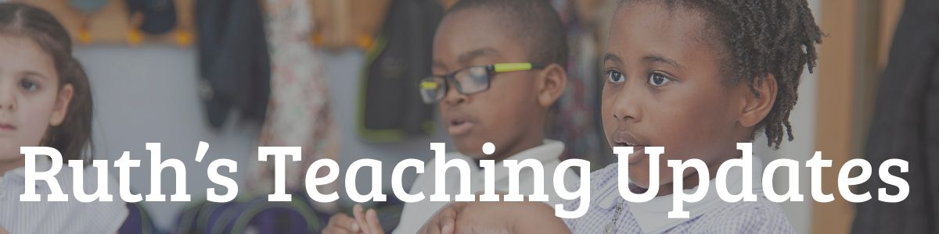

Sir Linkalot Time – Free Spelling Lessons

Watch daily episodes of Sir Linkalot Time & chat (with special guest appearances from TV’s Susie Dent) Monday to Friday at 2pm.

A brilliant way to learn the spelling of tricky words from ‘they’ to ‘onomatopoeia’.

The app won the ‘Best Educational App’ award at this year’s BETT Show – the world’s no 1 edtech exhibition.

So, tell your children (5 to 15 year olds) to ‘Tune in at 2pm for Sir Linkalot Time’ by clicking here.

