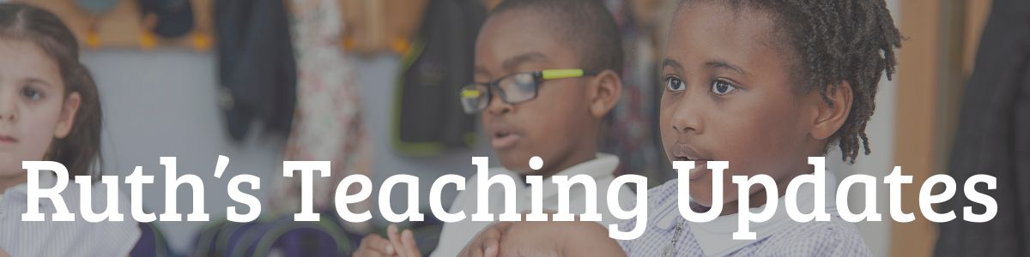

7 new YouTube Speed Sounds lessons every day on YouTube from Monday 20th April.
From Monday 20th April, we are streaming 7 Speed Sounds lessons, including Word Time and Spelling, for children to watch at home every weekday on our YouTube channel.
Each lesson is ten to fifteen minutes long and available for 24 hours.
Set 1
- Set 1 Speed Sounds 9.30 am (BST)
- Set 1 Word Time 9.45 am
- Set 1 Spelling 10.00 am
Set 2
- Set 2 Speed Sounds and Word Time 10.00 am
- Set 2 Spelling 10.15 am
Set 3
- Set 3 Speed Sounds and Word Time 10.30 am
- Set 3 Spelling 10.45 am
Once each complete set has been shown, we will replay one sound a day per set.
Click here for our YouTube Speed Sounds Lessons schedule

Storytime with Nick
From Monday 20th April, we are releasing Storytime with Nick; films of well-loved stories read by Nick Cannon, a trained actor, teacher and trainer and a wonderful storyteller. See him in action here.
A new story will be added to our YouTube channel at 2pm on Monday, Wednesday and Friday each week. They are ideal for Nursery, Reception and KS1 children.
Storytime includes books by Tom Percival, Cressida Cowell, David Melling, Jeanne Willis, Judith Kerr, Oliver Jeffers and David Walliams.
Most films will be available for the period of school closure.
Parent films
We have two new parent films available on our YouTube Channel:
- Reading Set 3 Speed Sounds and words with your child
- Introduction to daily Phonics lessons.
Please refer parents to our home reading page for information and parent resources.

