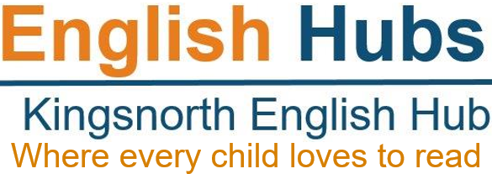

English Hubs: Expression of Interest Form
Facilitating excellent teaching of reading and early language in Reception and KS1
We are delighted that you are interested in the support in early language and reading teaching that we are offering as an English Hub school.
Our aim in 2019/20 is to provide high quality insight and advice to enable you to develop your own excellent practice in teaching reading through systematic synthetic phonics and early language, and encouraging a love of reading among your pupils.
The support that we can offer includes:
- attending a showcase of best practice in the teaching of early language and reading through systematic synthetic phonics
- help developing your own action plan for improving teaching of early language and reading
- financial support to buy resources that you have identified in your action plan
- a detailed in-school audit of your teaching provision, for those schools that would most benefit.
Please provide as much information below as possible. We will use this to prioritise among schools where there are more applications than we can accommodate.
School Name |  |  |  |  |  |  | URN
School Postcode
Headteacher’s name
English/Phonics Lead’s name
Contact details | Phone number:  Email address:
Number of pupils on roll for Reception and Key Stage 1 | Year R |  |  | Year 1 |  |  |  | Year 2
 | All Pupils | Disadvantaged |  | All Pupils |  | Disadvantaged |  | All Pupils |  | Disadvantaged
Year R – Baseline  2018-2019 | All Pupils |  |  |  |  | Disadvantaged Pupils
 | Speaking |  | Reading |  |  | Speaking |  |  | Reading
Any early language screening programme used | (i.e. language link, Nuffield Early Language Intervention (NELI)
Year R – GLD - Good Level of Development | 2019 |  |  | 2018 |  |  |  | 2017
 | All Pupils | Disadvantaged |  | All Pupils |  | Disadvantaged |  | All Pupils |  | Disadvantaged
Year R - ELG – composite measure for communication, language and literacy | 2019 |  |  | 2018 |  |  |  | 2017
 | All Pupils | Disadvantaged |  | All Pupils |  | Disadvantaged |  | All Pupils |  | Disadvantaged
Year 1 - Phonics Screening Check scores for the last three years | 2019 |  |  | 2018 |  |  |  | 2017
 | All Pupils | Disadvantaged |  | All Pupils |  | Disadvantaged |  | All Pupils |  | Disadvantaged
Any relevant contextual information about your PSC scores
Year 2 Phonic Screener Check  Re-Check | 2019 |  |  | 2018 |  |  |  | 2017
 | All Pupils | Disadvantaged |  | All Pupils |  | Disadvantaged |  | All Pupils |  | Disadvantaged
Key Stage 1 Reading assessment scores  Summer 2019 | 2019 |  |  | 2018 |  |  |  | 2017
 | All Pupils | Disadvantaged |  | All Pupils |  | Disadvantaged |  | All Pupils |  | Disadvantaged
Key Stage 2 Reading assessment scores  Summer 2019 | 2019 |  |  | 2018 |  |  |  | 2017
 | All Pupils | Disadvantaged |  | All Pupils |  | Disadvantaged |  | All Pupils |  | Disadvantaged
Proportion of children eligible for the pupil premium in the school |  |  |  |  | xx %
Is your school in an Opportunity Area? |  |  |  |  | Yes/No
Most recent Ofsted inspection grade and any additional points of relevance | Outstanding / Good / Requires Improvement / Special Measures
Please outline any other support that you are currently receiving in early language or literacy
Which phonics programme is used across your school?
(Briefly describe how this is implemented across your school)
Please briefly describe what you hope to achieve as a result of the support from an English Hub
Headteacher’s signature
Date

