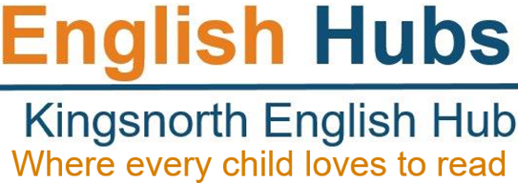

English Hubs: Expression of Interest Form
Facilitating excellent teaching of reading and early language in Reception and KS1
We are delighted that you are interested in the support in early language and reading teaching that we are offering as an English Hub school.
Our aim in 2022/2023 is to provide high quality insight and advice to enable you to develop your own excellent practice in teaching reading through systematic synthetic phonics and early language, and encouraging a love of reading among your pupils.
The support that we can offer includes:
- a detailed in-school audit of your teaching provision for phonics and early reading
- attending a showcase of best practice in the teaching of early language and reading through systematic synthetic phonics
- financial support to buy resources for a DfE validated SSP programme
Please provide as much information below as possible. We will use this to prioritise among schools where there are more applications than we can accommodate.
School Name |  |  |  |  |  |  |  | URN
School Address

School phone no.
MAT name if applicable
Number of children on roll |  |  |  | Number of children in: |  | Year R |  |  |  | Year 1 |  |  | Year 2
Headteacher’s name & email
English/Phonics Lead name & email
% of Pupil Premium
Year R – GLD - Good Level of Development | 2018 |  | 2019 |  |  |  |  |  | 2022
Phonics Screening Check scores | 2018 | 2019 |  |  | Autumn 2020  Year 2 (non published) |  | Summer 2021  (non-published) |  |  |  |  | 2022
Key Stage 1 Reading assessment scores | 2018 |  | 2019 |  |  |  |  |  | 2022
Key Stage 2 Reading assessment scores | 2018 |  | 2019 |  |  |  |  |  | 2022

Phonics Scheme currently used and for how long

Any relevant contextual information about your PSC scores

Other relevant information e.g. high EAL, SEND,
Most recent Ofsted inspection grade and any additional points of relevance | Outstanding / Good / Requires Improvement / Special Measures  Last inspection date?
Please outline any other support that you are currently receiving in early language or literacy
Please briefly describe what you hope to achieve as a result of the support from an English Hub
Please tell us how you found out about the English Hub?

Have you attended any recent training?
Headteacher’s signature
Date

