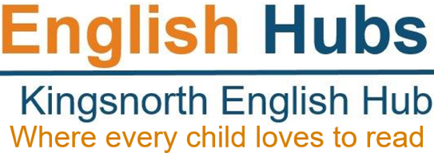

English Hubs: Expression of Interest Form
Facilitating excellent teaching of reading and early language in Reception and KS1
We are delighted that you are interested in the support in early language and reading teaching that we are offering as an English Hub school.
Our aim in 2023/2024 is to provide high quality insight and advice to enable you to develop your own excellent practice in teaching reading through systematic synthetic phonics and early language, and encouraging a love of reading among your pupils.
The support that we can offer includes:
- a detailed in-school audit of your teaching provision for phonics and early reading
- financial support to buy resources for a DfE validated SSP programme
- literacy specialist days to support your reading leader with effective phonic teaching, assessments, interventions and staff coaching
Please provide as much information below as possible. We will use this to prioritise among schools where there are more applications than we can accommodate.
School Name |  |  |  |  |  |  |  | URN
School Address & postcode
School phone no.
MAT name if applicable
Number of children on roll |  |  |  |  | Number of children in: |  | Year R |  |  | Year 1 |  |  | Year 2
Headteacher’s name & email
English/Phonics Lead name & email
Finance Officer
name & email
% of Pupil Premium
Other relevant information e.g. high EAL, SEND, GRT
Yr 1 Phonic Screening Check scores | 2019 |  |  | 2022 |  |  |  |  | 2023
 | All pupils | Disadvantaged |  | All pupils |  | Disadvantaged |  |  | All pupils |  |  | Disadvantaged
Any relevant contextual information about your PSC scores
Is there low achievement in your lowest 20%?
Is there a higher than average percentage of low achieving pupils?
Phonics Scheme currently used and for how long

KS1 Reading Assessment Scores | 2019 |  | 2022 |  |  |  | 2023
 | All pupils | Disadvantaged | All pupils | Disadvantaged |  |  | All pupils | Disadvantaged
KS2 Reading Assessment Scores | 2019 |  | 2022 |  |  |  | 2023
 | All pupils | Disadvantaged | All pupils | Disadvantaged |  |  | All pupils | Disadvantaged
Most recent Ofsted inspection grade and any additional points of relevance | Inspection date: |  |  | Grade:
 | Other info:
Have Ofsted identified phonics as an area for development?
Is there a risk of declining standards in phonics? –
If ‘yes’ please explain:
Please briefly describe what you hope to achieve as a result of the support from an English Hub
Please tell us how you found out about the English Hub?
Have you attended any recent training?
Have you previously had any funding to support or resource phonics in your school?
Headteacher’s signature |  |  |  |  | Date:

